DAY 2
COMPARISON SCREENSHOTS
Lazy prompt output:
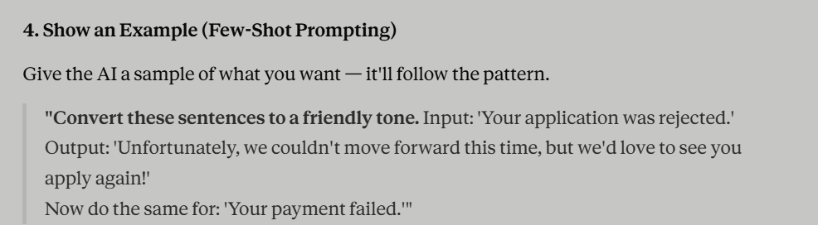
MetaPrompt optimised prompt output:
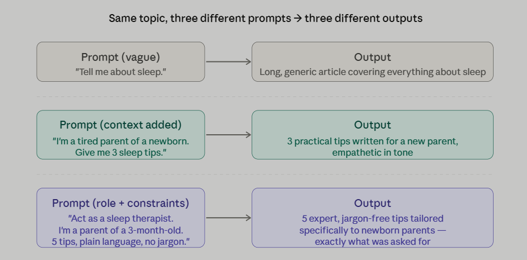
From this screenshots observation we can say that optimised prompt gives the best understanding about a topic in depth.

